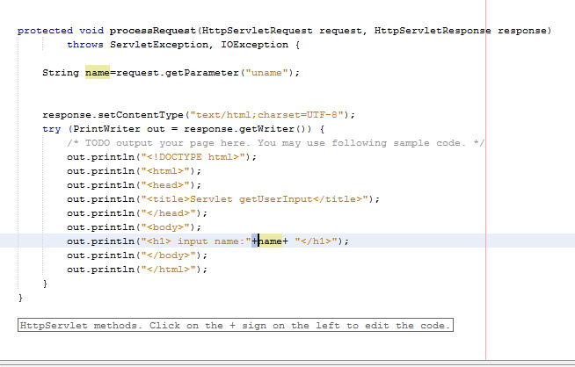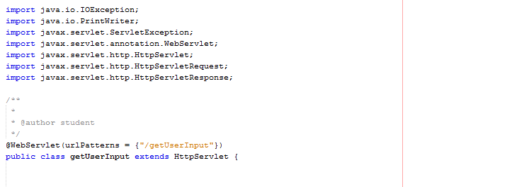Java Servlet Practical Lab Sheet  
  
Lab Task 2: Get User Input from Form and Display  
  
Servlet Code (GetUserInputServlet.java):

Index.html

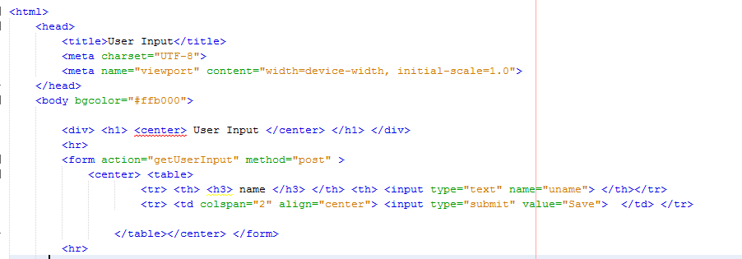

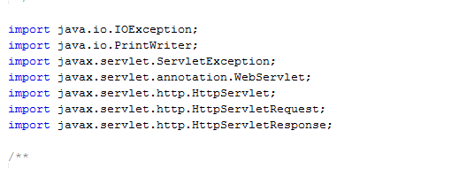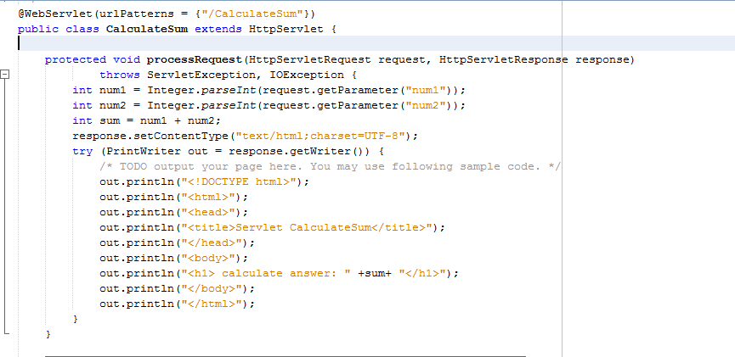Lab Task 3: Get Multiple Inputs, Perform Calculation, and Display Result  
  
Servlet Code (CalculateSumServlet.java):

HTML Form (calculate.html):

